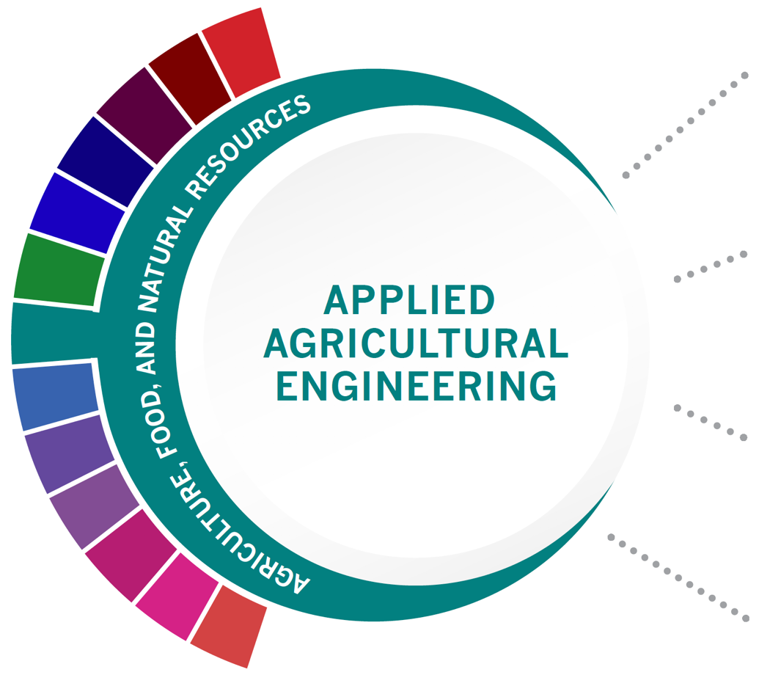
Statewide Program of Study: Applied Agricultural Engineering; Agriculture, Food, and Natural Resources Career Cluster
Level 1 | Principles of Agriculture, Food, and Natural Resources
Level 2 | Agricultural Mechanics and Metal Technologies/Lab
Level 3 | Agricultural Structures Design and Fabrications/Lab
Level 4 | Agricultural Equipment Design and Fabrication/Lab

HIGH SCHOOL/ INDUSTRY CERTIFICATION | CERTIFICATE/ LICENSE* | ASSOCIATE’S DEGREE | BACHELOR’S DEGREE | MASTER’S/ DOCTORAL PROFESSIONAL DEGREE
OSHA 30 Hour General Industry | Certified Professional Agronomist | Heavy Equipment Maintenance Technology/  Technician | Agricultural Engineering | Agricultural Engineering
Feedyard Technician in Machinery, Operation, Repair and Maintenance | Certified Reliability Engineer | Agricultural Mechanization, General | Agricultural Mechanization, General | Agricultural Mechanization, General
AWS SENSE Welding Level 1 | Certified Irrigation Designer | Small Engine Mechanics and Repair Technology/  Technician
AWS D1.1 or D9.1 Certification | Fluid Power Mobile Hydraulic Mechanic | Welding Technology/  Welder
Additional industry-based certification information is available on the TEA CTE website. For more information on postsecondary options for this program of study, visit TXCTE.org.
Occupations | Median Wage | Annual Openings | % Growth
Outdoor Power Equipment and Other Small Engine Mechanics | $32,406 | 366 | 16%
Welders | $41,350 | 6,171 | 9%
Farm Equipment Mechanics and Service Technicians | $39,915 | 304 | 17%
Mobile Heavy Equipment Mechanics | $47,299 | 1,627 | 16%
Agricultural Engineers | $64,792 | 9 | 13%

WORK BASED LEARNING AND EXPANDED
LEARNING OPPORTUNITIES
Exploration Activities: | Work Based Learning  Activities:
Tour a farm products or machinery plant  Texas FFA | Earn a welding certification  Intern at a farm products or machinery plant  FFA Supervised Agriculture Experience (SAE)

The Applied Agricultural Engineering program of study explores the occupations and educational opportunities associated with applying knowledge of engineering technology and biological science to agricultural problems concerned with power and machinery, electrification, structures, soil and water conservation, and processing agricultural products. This program of study may also include exploration into diagnosing, repairing, or overhauling farm machinery and vehicles, such as tractors, harvesters, dairy equipment, and irrigation systems.
The Agriculture, Food, and Natural Resources (AFNR) Career Cluster focuses on the essential elements of life—food, water, land, and air. This career cluster includes a diverse spectrum of occupations, ranging from farmer, rancher, and veterinarian to geologist, land conservationist, and florist. It also includes non-traditional agricultural occupations like wind energy, solar energy, and oil and gas production.

Successful completion of the Applied Agricultural Engineering program of study will fulfill requirements of a Business and Industry endorsement or STEM endorsement if the math and science requirements are met. Revised - July 2020

COURSE INFORMATION

COURSE  NAME | SERVICE ID | PREREQUISITES (PREQ)  COREQUISITES (CREQ) | Grade
Principles of Agriculture, Food, and Natural Resources | 13000200 (1 credit) | None | 9-12
Agricultural Mechanics and Metal Technologies/Lab | 13002200 (1 credit)  13002210 (2 credits) | None | 10-12
Agricultural Structures Design and Fabrications/Lab | 13002300 (1 credit)  13002310 (2 credits) | None | 11-12
Agricultural Equipment Design and Fabrication/Lab | 13002350 (1 credit)  13002360 (2 credits) | None | 11-12

FOR ADDITIONAL INFORMATION ON THE AGRICULTURE, FOOD, AND NATURAL RESOURCE CAREER CLUSTER,
PLEASE CONTACT: CTE@tea.texas.gov
https://tea.texas.gov/cte

(District) offers career and technical education programs in (types of programs offered). Admission to these programs is based on (admission standards). It is the policy of (District) not to discriminate on the basis of race, color, national origin, sex or handicap in its vocational programs, services or activities as required by Title VI of the Civil Rights Act of 1964, as amended; Title IX of the Education Amendments of 1972; and Section 504 of the Rehabilitation Act of 1973, as amended. It is the policy of (District) not to discriminate on the basis of race, color, national origin, sex, handicap, or age in its employment practices as required by Title VI of the Civil Rights Act of 1964, as amended; Title IX of the Education Amendments of 1972; the Age Discrimination Act of 1975, as amended; and Section 504 of the Rehabilitation Act of 1973, as amended. (District) will take steps to assure that lack of English language skills will not be a barrier to admission and participation in all educational and vocational programs. For information about your rights or grievance procedures, contact the Title IX Coordinator at (physical address of Coordinator) (email address of Title IX Coordinator), (phone number of Title IX Coordinator), and the Section 504 Coordinator at (physical address of Coordinator), (email address of Section 504 Coordinator), (phone number of Section 504 Coordinator)

